Module 1
Integers Diagnostic
Compare. Write < , > or = for each

- 16,034 _______ 16,134
- 458,764 ________ 45,976
- 42,245,589 __________ 42,245,598
- 946,548,620 _________ 946,548,619

Graph Numbers on a Number Line
Graph each number on the number line
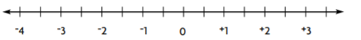

- 2
- -3
- 0.5
- -2

Order Whole Numbers

Order the numbers from greatest to least.

- 584 3,896 3,215
Order __________________________

- 46,205 46,250 46,215
Order ________________________

Order the numbers from least to greatest.

- 348 327 316
Order ___________________________

- 835 1,218 1,409 1,401
Order ___________________________

