Module 1 Diagnostic
Answer Key
- <
- >
- <
- >
5.
6.
7.
8.

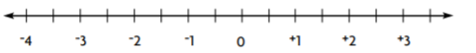
9. 3,896 3,215 584
10. 46,250 46,215 46,205
11. 316 327 348
12. 835 1,218 1,401 1,409

